Module 1

**Artificial Intelligence (AI) :-**

Artificial Intelligence is composed of two words Artificial and Intelligence, where Artificial defines "man-made," and intelligence defines "thinking power", hence AI means "a man-made thinking power."  
Artificial Intelligence exists when a machine can have human based skills such as learning, reasoning, and solving problems

**AI Perspectives: Acting and Thinking humanly, Acting and Thinking rationally** ➖

**History of AI**

**Application of AI**

**The present state of AI**

**Ethics in AI**

Module 2

**Introduction of agents**  
An agent can be anything that perceiveits environment through sensors and act upon that environment through actuators. An Agent runs in the cycle of perceiving, thinking, and acting. An agent can be:  
Human-Agent

Robot-Agent

Software Agent

**Structure of Intelligent Agent**

The task of AI is to design an agent program which implements the agent function. The structure of an intelligent agent is a combination of architecture and agent program. It can be viewed as:

Agent = Architecture + Agent program

Following are the main three terms involved in the structure of an AI agent:

Architecture: Architecture is machinery that an AI agent executes on.

Agent Function: Agent function is used to map a percept to an action.

Agent program: Agent program is an implementation of agent function. An agent program executes on the physical architecture to produce function f.

**Characteristics of Intelligent Agents**

Intelligent agents have the following distinguishing characteristics:

* They have some level of autonomy that allows them to perform certain tasks on their own.
* They have a learning ability that enables them to learn even as tasks are carried out.
* They can interact with other entities such as agents, humans, and systems.
* New rules can be accommodated by intelligent agents incrementally.
* They exhibit goal-oriented habits.
* They are knowledge-based. They use knowledge regarding communications, processes, and entities.

**Types of Agents**

**Simple Reflex-**

The Simple reflex agents are the simplest agents. These agents take decisions on the basis of the current percepts and ignore the rest of the percept history.

These agents only succeed in the fully observable environment.

The Simple reflex agent does not consider any part of percepts history during their decision and action process.

The Simple reflex agent works on Condition-action rule, which means it maps the current state to action. Such as a Room Cleaner agent, it works only if there is dirt in the room.

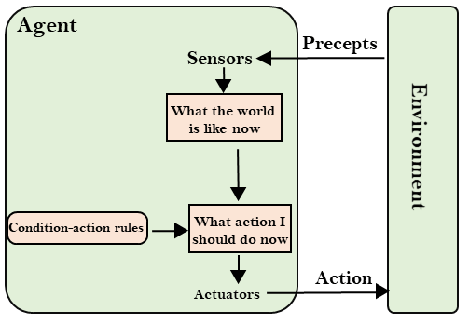

**Model Based-**

The Model-based agent can work in a partially observable environment, and track the situation.

A model-based agent has two important factors:

Model: It is knowledge about "how things happen in the world," so it is called a Model-based agent.

Internal State: It is a representation of the current state based on percept history.

These agents have the model, "which is knowledge of the world" and based on the model they perform actions.

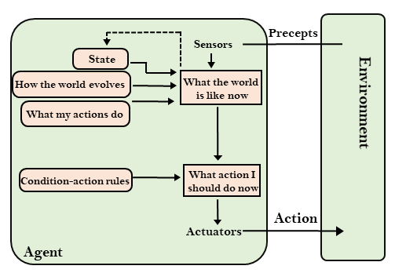

**Goal Based-**The knowledge of the current state environment is not always sufficient to decide for an agent to what to do.

The agent needs to know its goal which describes desirable situations.

Goal-based agents expand the capabilities of the model-based agent by having the "goal" information.

They choose an action, so that they can achieve the goal.

These agents may have to consider a long sequence of possible actions before deciding whether the goal is achieved or not. Such considerations of different scenario are called searching and planning, which makes an agent proactive.

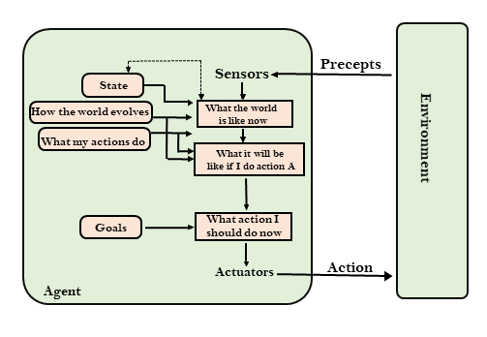

**Utility Based Agents-**

These agents are similar to the goal-based agent but provide an extra component of utility measurement which makes them different by providing a measure of success at a given state.

Utility-based agent act based not only goals but also the best way to achieve the goal.

The Utility-based agent is useful when there are multiple possible alternatives, and an agent has to choose in order to perform the best action.

The utility function maps each state to a real number to check how efficiently each action achieves the goals.

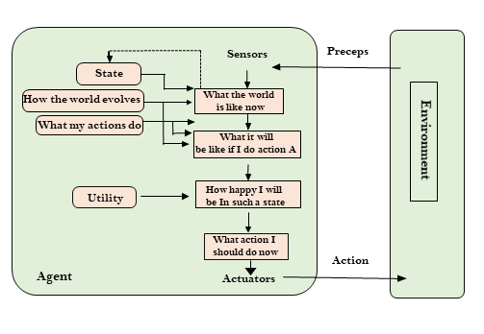

**Environment Types**

**Deterministic**

**Stochastic**

**Static, Dynamic**

**Observable**

**Semi-observable**

**Single Agent**

**Multi Agent**

Module 3  
Informed Serach VS Uninformed Search

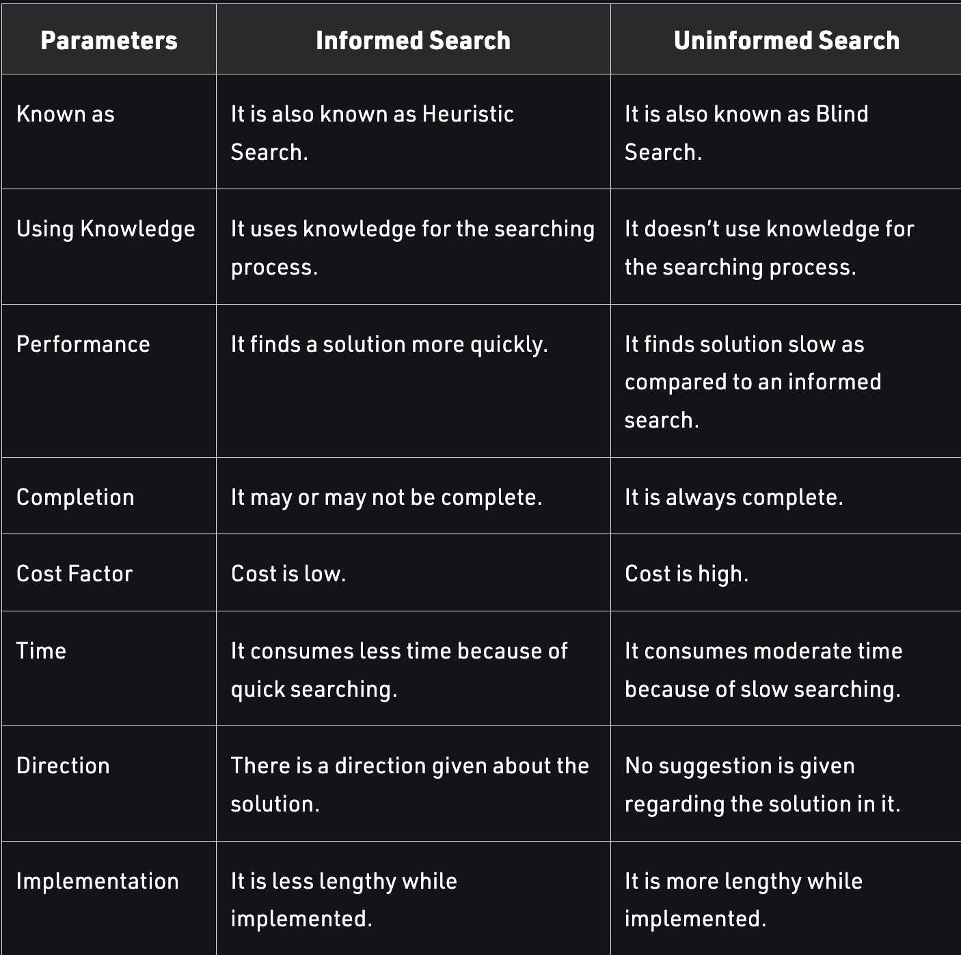

Properties of Search Algorithms: (**Mnemonics for remembering Properties → C.O.S.T**)

Following are the four essential properties of search algorithms to compare the efficiency of these algorithms:

* Completeness: A search algorithm is said to be complete if it guarantees to return a solution if at least any solution exists for any random input.
* Optimality: If a solution found for an algorithm is guaranteed to be the best solution (lowest path cost) among all other solutions, then such a solution for is said to be an optimal solution.
* Time Complexity: Time complexity is a measure of time for an algorithm to complete its task.
* Space Complexity: It is the maximum storage space required at any point during the search, as the complexity of the problem.

Uninformed:-

**DFS :-**

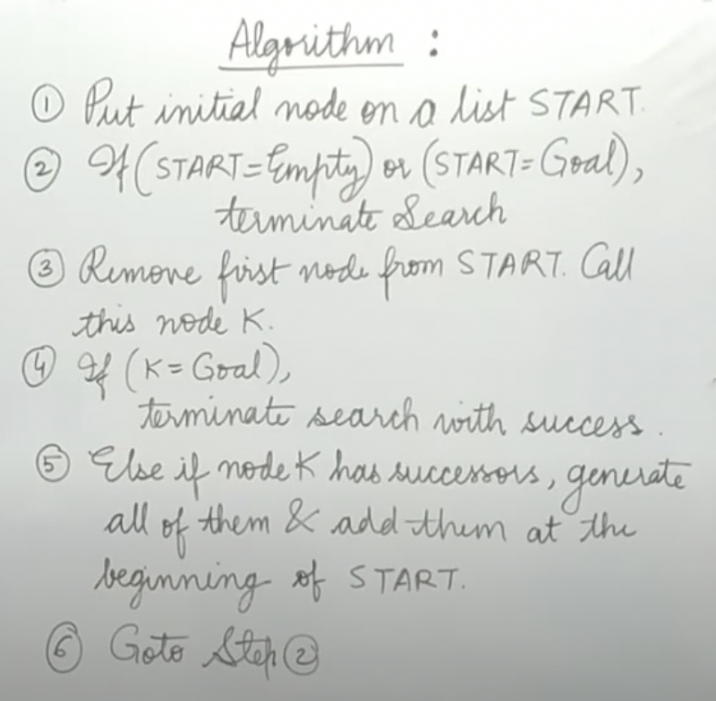

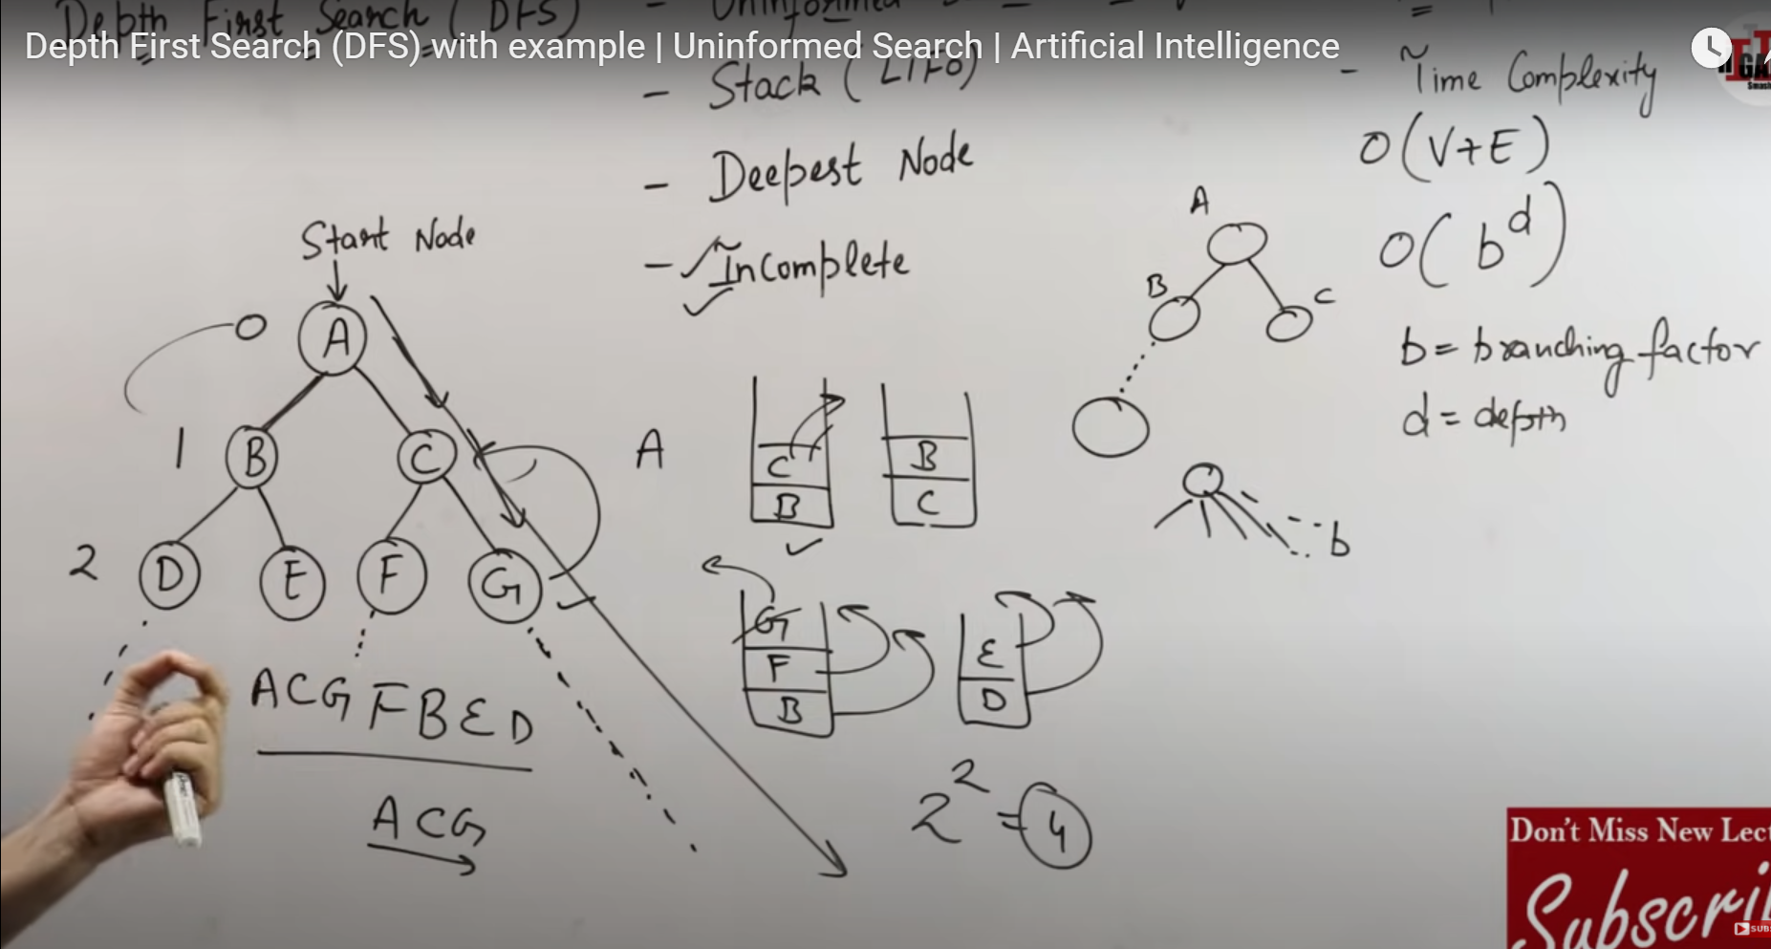

**Time Complexity = O(nm)**

**Space Complexity = O(bm)**

**m= maximum depth of any node and this can be much larger than d (Shallowest solution depth)**

**BFS**

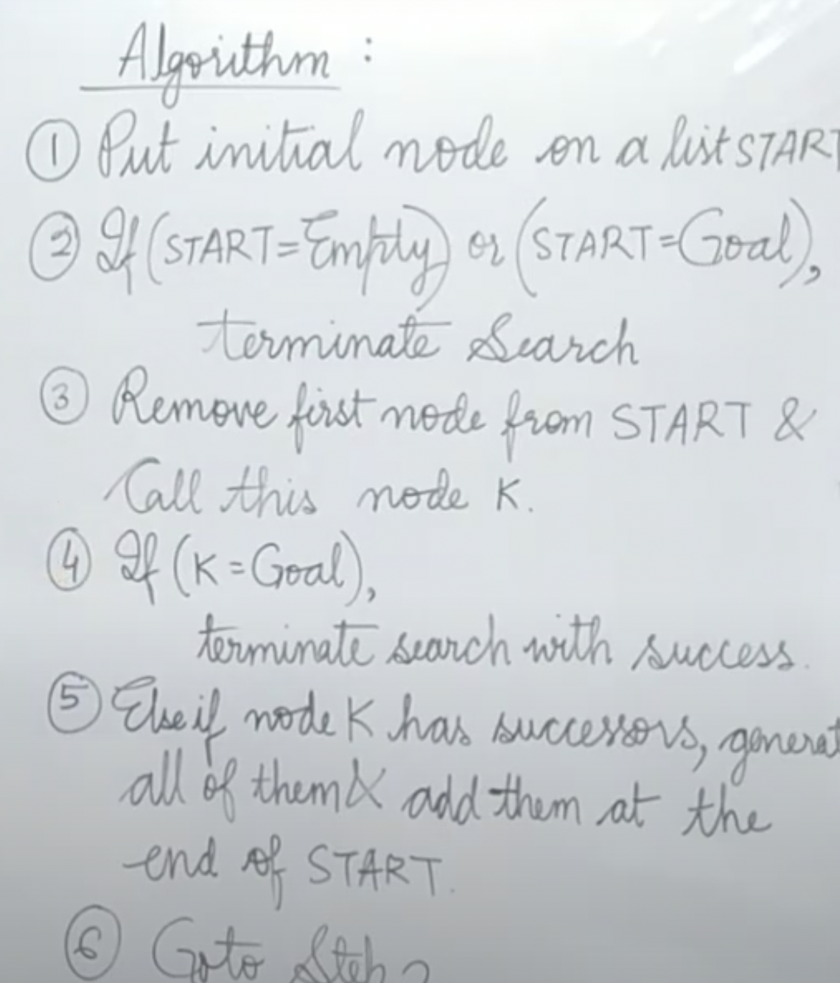

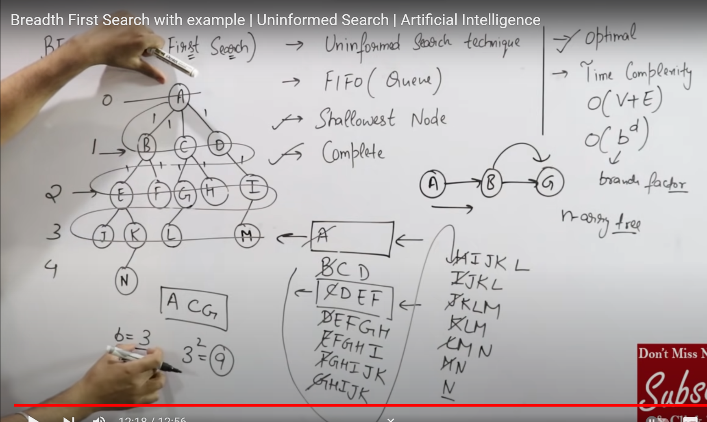

**Time Complexity = Space Complexity = O (bd)**

**d= depth of shallowest solution and b is a node at every state.**

Informed Search

**Hill Climbing Search**

Traverse Child based on Heuristic Value rest same as DFS

**BFS**

**A* search Informed search**

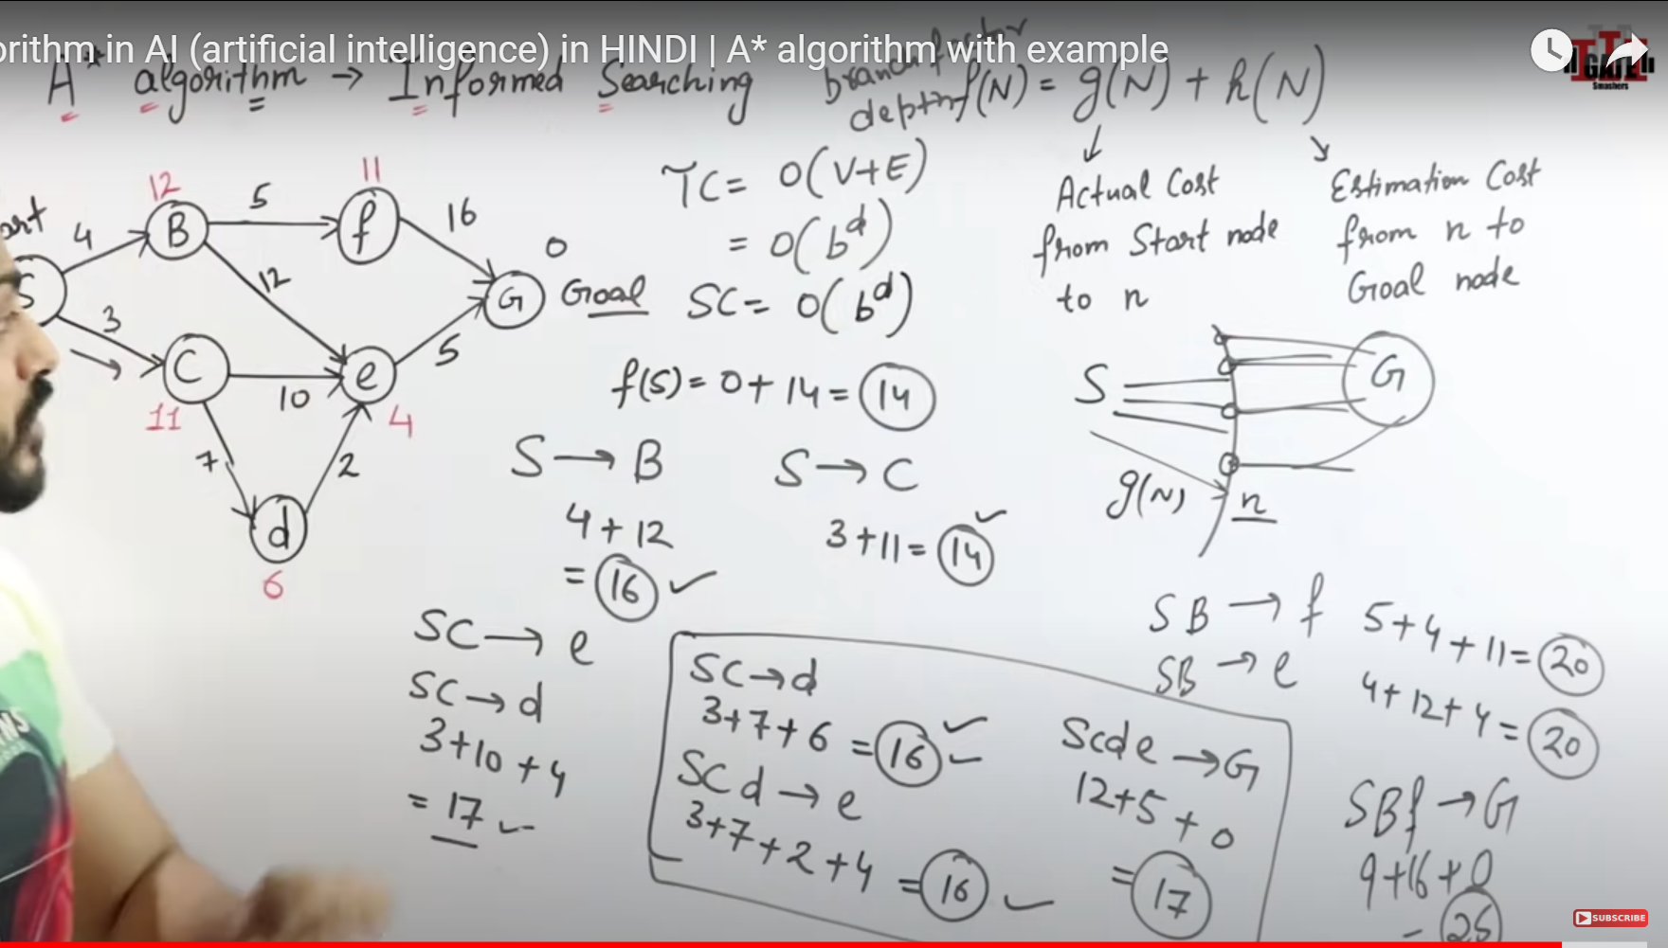

Game Playing

Game Playing is an important domain of artificial intelligence. Games don’t require much knowledge; the only knowledge we need to provide is the rules, legal moves and the conditions of winning or losing the game. Both players try to win the game. So, both of them try to make the best move possible at each turn. Searching techniques like BFS(Breadth First Search) are not accurate for this as the branching factor is very high, so searching will take a lot of time.

Min-Max Algoritm